Practical 11

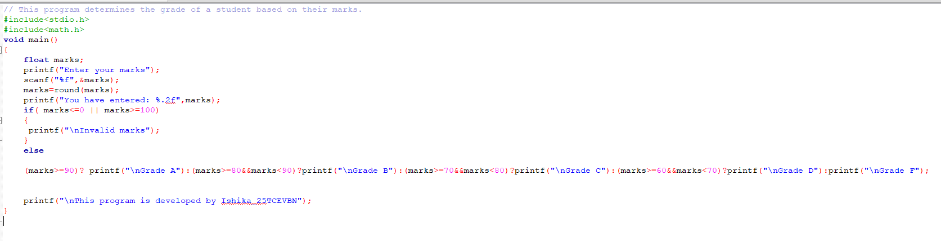

When invalid marks are entered

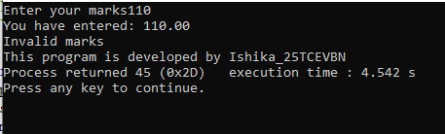

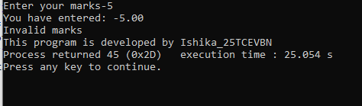

When valid marks are entered

